AllBazar: A Local Marketplace Web Application for Bangladesh

Submitted By

Student Name | Student ID
Arhab Jahin | 2|||-1||-||||

LAB PROJECT REPORT
This Report Presented in Partial Fulfillment of the course
CSE416: Web Engineering Lab in the Department of Computer Science and Engineering


DAFFODIL INTERNATIONAL UNIVERSITY
Dhaka, Bangladesh
28/04/2026

DECLARATION
We hereby declare that this lab project has been done by us under the supervision of Md.
Hasanuzzaman Dipu, Assistant Professor, Department of Computer Science and Engineering, Daffodil International University. We also declare that neither this project nor any part of this project has been submitted elsewhere as lab projects.

Submitted To:

Md. Hasanuzzaman Dipu
Assistant Professor
Department of Computer Science and Engineering
Daffodil International University

Submitted by
-----------  Dept. of CSE, DIU | Arhab Jahin  Dept. of CSE, DIU

COURSE & PROGRAM OUTCOME
The following course have course outcomes as following:

Table 1: Course Outcome Statements
CO’s | Statements
CO1 | Understand and apply web development concepts to design and develop a full-stack ecommerce application using modern frameworks and database systems.
CO2 | Apply appropriate programming techniques, tools, and frameworks such as Laravel, PHP, and MySQL to develop scalable and secure web applications.
CO3 | Perform effectively as an individual or a team member in developing modules such as authentication, product management, and order processing with proper documentation.
CO4 | Communicate effectively through technical reports, system design documentation, and presentations, demonstrating the ability to explain complex engineering activities.

Table 2: Mapping of CO, PO, Blooms, KP and CEP
Mapping Course Outcome (COs) with the Teaching-Learning and Assessment Strategy:
CO’s | Corresponding PO number | Domain  Level/  Learning  Taxonomy | Level of  Knowledge  Profile (K) | Complex  Engineering  Problem  (EP) | Complex  Engineering  Activities  (EA)
CO1 | PO1 | C1, C2 | K1-K4 | EP1 | EA1
CO2 | PO5 | C3, C4 | K1-K4, K6 | EP1, EP3 | EA3
CO3 | PO9 | C4, A2 | K6 | EP1, EP3 | EA2
CO4 | PO10 | C6, P3, A2 | K4 | EP3, EP5 | EA3

The mapping justification for this table is provided in sections 4.2.1, 4.2.2, and 4.2.3, where the relationship between course outcomes, program outcomes, complex engineering problems, and engineering activities is explained in the context of the ShopWave e-commerce system.

Table of Contents
Declaration i
Course & Program Outcome ii
1 Introduction 1
1.1 Introduction 2
1.2 Motivation 3
1.3 Objectives 4
1.4 Project Outcome 5
2 Architecture 6
2.1 Requirement Analysis & Design Specification 6
2.1.1 Requirements 6
2.1.2 UI Images 7
2.2 Use of Modern Tools 9
3 Implementation and Results 9
3.1 Implementation 9
3.2 Output 9
3.3 Discussion 10
4 Engineering Standards and Mapping 10
4.1 Impact on Society, Environment and Sustainability 10
4.1.1 Impact on Life 10
4.1.2 Impact on Society & Environment 11
4.2 Complex Engineering Problem 12
4.2.1 Mapping of Program Outcome 12
4.2.2 Complex Problem Solving 12
4.2.3 Engineering Activities 13
5 Conclusion 13
5.1 Summary 14
5.2 Limitation 14
5.3 Future Work 14
5.4 Github & YT link 14
References 15

Chapter 1

Introduction

This chapter provides an overview of the AllBazar Local Marketplace Web Application, including its purpose, motivation, objectives, feasibility, gap analysis, and expected project outcomes. AllBazar is designed as a modern online marketplace for Bangladesh where customers can search for products from different nearby shops, compare prices, check distance, view ratings, add products to cart, and place orders online.
Unlike a traditional e-commerce website that sells products from one store only, AllBazar allows multiple local shops to join the platform and list their products. Customers can find the same or similar products from different shops and choose the best option based on price, distance, rating, delivery charge, and product availability. The platform is inspired by the idea of combining the local delivery experience of Foodpanda with the product variety of Daraz.
The system is developed using Laravel, PHP, HTML, CSS, JavaScript, and MySQL. It follows the MVC architecture, which separates business logic, database operations, and user interface design. This improves maintainability, scalability, and future development.

1.1 Introduction
AllBazar is a Laravel-based local marketplace web application for Bangladesh. It is designed to connect customers with nearby shops and make local shopping easier, faster, and more organized. Any shop can become part of AllBazar and list its products. Customers can search for any product and see results from multiple shops with different prices, delivery costs, distances, ratings, and stock information.
The main goal of the system is to help users compare the same or similar products from multiple shops. For example, if a customer searches for a mobile charger, AllBazar will show chargers from different shops. Products with cheaper prices and closer shop locations are prioritized in the result list. This helps customers make better buying decisions.
The website includes customer features, shop-owner features, and admin features. Customers can browse products, use advanced search, add products to cart, place orders, save wishlist items, and write reviews. Shop owners can register their shops, add products, manage stock, upload product images, and view orders. Admins and co-admins can manage users, shops, products, categories, orders, support messages, and shop approval.

1.2 Motivation
The motivation behind AllBazar is to:
- Make local shopping easier and faster.
- Help customers find nearby shops.
- Allow customers to compare prices from different shops.
- Support small and local businesses in Bangladesh.
- Reduce the time and effort required for physical shopping.
- Create a marketplace where any shop can join and sell products.
- Provide a digital platform for shop owners to manage products and orders.
- Build a scalable web application using Laravel and MySQL.

1.3 Objectives

The main objectives of AllBazar are:
- To develop a full-stack local marketplace web application.
- To allow customers to search for products from multiple shops.
- To rank products based on price, distance, and rating.
- To provide advanced search filters for price, category, shop area, delivery cost, rating, and stock.
- To allow customers to view product details, product images, reviews, and shop information.
- To allow customers to add products to cart and place orders.
- To provide customer account management with profile, wishlist, saved addresses, order history, and reviews.
- To allow shop owners to register shops and manage products.
- To allow admins to manage users, shops, products, categories, orders, support messages, and co-admin roles.
- To create a responsive and user-friendly interface for desktop, tablet, and mobile users.
- To use Laravel MVC architecture for clean and scalable development.

1.4 Feasibility Study

Technical Feasibility
The AllBazar application is technically feasible because it uses widely used and well-supported technologies. Laravel is a powerful PHP framework that supports routing, controllers, models, Blade templates, validation, authentication, middleware, and database management. MySQL is used for storing users, shops, products, orders, reviews, and other data.
The project uses the following technologies:
- PHP
- Laravel
- HTML
- CSS
- JavaScript
- MySQL
- XAMPP
- Blade Template Engine
These technologies are suitable for building a dynamic marketplace website. Laravel’s MVC structure makes the project easier to organize and maintain.

Economic Feasibility
The project is economically feasible because most of the technologies used are open-source and free. Laravel, PHP, MySQL, XAMPP, HTML, CSS, and JavaScript do not require licensing fees. The development can be completed using commonly available tools such as VS Code and XAMPP.
The cost is low because:
- Open-source technologies are used.
- No paid software is required for development.
- Local testing can be done using XAMPP.
- The system can later be hosted on affordable web hosting services.
- The website can help local shops increase sales without building their own website.

Operational Feasibility
AllBazar is operationally feasible because it is designed with a clean and user-friendly interface. Customers can easily search for products, compare prices, add products to cart, and place orders. Shop owners can manage shops and products through a dashboard. Admins can control the whole system through an admin panel.
The system is easy to use for:
- Customers
- Shop owners
- Admins
- Co-admins
The design is responsive, so users can access the website from mobile phones, tablets, and computers.

Schedule Feasibility
The project can be completed within a reasonable academic timeline because Laravel provides built-in support for routing, MVC structure, authentication, validation, database migrations, and controllers. The system is divided into modules, so each part can be developed step by step.
Main development phases:
- Requirement analysis
- Database design
- Frontend design
- Authentication system
- Product and shop management
- Cart and checkout system
- Admin dashboard
- Testing and debugging
- Report preparation

1.5 Gap Analysis
Gap analysis identifies the difference between the current system and the desired system.
Existing System
In the traditional local shopping system:
- Customers need to visit shops physically.
- Product availability is not known before visiting a shop.
- Price comparison is difficult.
- Customers cannot easily know which nearby shop has the product.
- Shop owners depend mostly on offline customers.
- Small shops do not have a proper digital presence.
- Order management is manual.
- Customer reviews and ratings are not centralized.
- Delivery cost comparison is not available.

Proposed System: AllBazar
AllBazar provides a digital solution where:
- Customers can search products online.
- Multiple shops can list their products.
- Customers can compare prices from different shops.
- Nearby shops can be shown based on distance.
- Product results can be ranked by price, distance, and rating.
- Customers can add items to cart and place orders.
- Shop owners can manage products and orders.
- Admins can approve shops and manage platform data.
- Reviews, ratings, wishlist, support, and order tracking are available.

Gap Bridging Strategy
- Using Laravel MVC architecture.
- Creating separate dashboards for customers, shop owners, and admins.
- Implementing product search and advanced filtering.
- Ranking products based on price, distance, and rating.
- Providing cart, checkout, wishlist, and review features.
- Creating a support system for users.
- Making the website responsive for all devices.

1.6 Project Outcome

The final system, AllBazar, is a functional local marketplace web application that successfully integrates modern web technologies and software engineering practices. The system provides a complete platform for online product searching, shop discovery, cart management, order processing, and marketplace administration.
The key outcomes of the project are as follows:
- Secure Authentication System
The application includes registration, login, logout, and role-based access. Users can register as customers or shop owners. Admins and co-admins can access the admin dashboard.
- Product Search and Advanced Filtering
Customers can search products by name, category, and type. Advanced filters allow users to search by price range, distance, delivery cost, shop rating, product rating, stock, and area.
- Price and Distance-Based Ranking
The system ranks products based on important marketplace factors such as product price, shop distance, and rating. Cheaper and nearby products are prioritized to help customers make better purchasing decisions.
- Product and Shop Management
Shop owners can register or update shops, add products, upload images, set category, type, price, discount price, stock, description, and featured status.
- Cart and Checkout System
Customers can add products to cart, update quantities, remove products, view subtotal, delivery cost, discount, total amount, and proceed to checkout.
- Customer Dashboard
Customers can manage their profile, saved addresses, wishlist, order history, and submitted reviews.
- Review and Wishlist System
Logged-in users can review products and shops. They can also save products to their wishlist for later purchase.
- Admin and Co-admin Dashboard
Admins can manage users, roles, shops, products, categories, orders, support messages, and co-admin access.
- Support System
Users and visitors can send support messages with name, email, phone, subject, and message. Admins can review and update support message status.
- Responsive User Interface
The website has a modern and mobile-friendly design with sticky navigation, hamburger menu, product cards, shop cards, category tiles, dashboards, forms, alerts, and tables.

Chapter 2

System Architecture/ Scene Description & Architecture
This chapter describes the system architecture, requirement analysis, design specification, tools, modules, database design, and main code structure of the AllBazar marketplace web application.
AllBazar follows the MVC architecture provided by Laravel. MVC stands for Model, View, and Controller. Models handle database interaction, views handle the user interface, and controllers handle business logic and communication between models and views.

2.1 Requirement Analysis & Design Specification
Requirement analysis is an important part of software development. It identifies what the system should do and how the system should perform.

2.1.1 Requirements

User Authentication
- User registration
- User login
- User logout
- Remember me option
- Customer registration
- Shop owner registration
- Admin login
- Role-based access control

Homepage
- Marketplace hero section
- Product search bar
- Autocomplete suggestions
- Advanced search shortcut
- Shop map shortcut
- Product categories
- Featured shops
- Popular products
- Nearby products
- Today’s deals
- Marketplace statistics

Product Search
- Search by product name
- Search by category
- Search by type
- Similar product matching
- Product grouping by name
- Ranking by price, distance, and rating
- Search suggestions

Advanced Search
- Filter by product name
- Filter by category
- Filter by minimum price
- Filter by maximum price
- Filter by distance
- Filter by delivery cost
- Filter by shop rating
- Filter by product rating
- Filter by stock availability
- Filter by area/location
- Sort by cheapest
- Sort by nearest
- Sort by best-rated
- Sort by newest

Product Details
- Product image/gallery
- Click-to-zoom image
- Product name
- Category and type
- Current price
- Old price
- Discount badge
- Description
- Stock information
- Delivery cost
- ETA
- Rating
- Shop profile link
- Add to cart
- Buy now
- Specifications
- Customer reviews
- Related products
- Recently viewed products

Shop Features
- Featured shop cards
- Shop profile page
- Shop logo
- Shop banner
- Shop area
- Shop distance
- Shop rating
- Shop phone
- Shop address
- Shop products
- Shop categories
- Shop reviews
- Shop review form
- Visual shop location card

Shop Map
- Map-style shop layout
- Shop pins
- Clickable shop icons
- Filter by shop name
- Filter by area
- Filter by category
- Filter by rating
- Filter by distance

Cart
- Add product to cart
- View cart
- Update quantity
- Remove product
- Show unit price
- Show line total
- Show subtotal
- Show delivery charge
- Show discount
- Show total amount
- Proceed to checkout

Checkout
- Recipient name
- Phone number
- Delivery address
- Area
- City
- Payment method
- Cash on Delivery
- Mobile Banking
- Card payment option
- Order notes
- Order summary
- Order tracking flow

Order Management
- Place order
- View order history
- View order details
- Order status update
- Pending status
- Accepted status
- Processing status
- Out for Delivery status
- Delivered status
- Cancelled status

Customer Account
- Customer dashboard
- Profile information
- Edit profile
- Change password
- Saved address count
- Add saved address
- Delete saved address
- Mark default address
- Wishlist count
- Wishlist products
- Submitted reviews
- Order history

Wishlist
- Save products
- View saved products
- Remove saved products
- Guest users redirected to login

Reviews
- Product review
- Shop review
- Rating
- Comment
- Customer review dashboard

Shop Owner Dashboard
- Shop owner overview
- Number of shops
- Listed products
- Recent orders
- Register shop
- Update shop
- Add products
- Upload product images
- Edit own products
- Delete own products
- Delete product images
- View recent orders
- Update order status

Admin Dashboard
- Manage users
- Manage user roles
- Promote co-admins
- Remove co-admins
- Manage shops
- Approve shops
- Update shop status
- Manage products
- Manage categories
- View orders
- View support messages
- Update support status

Static Pages
- About page
- Support page
- Terms page
- Privacy page

2.1.2 UI Images

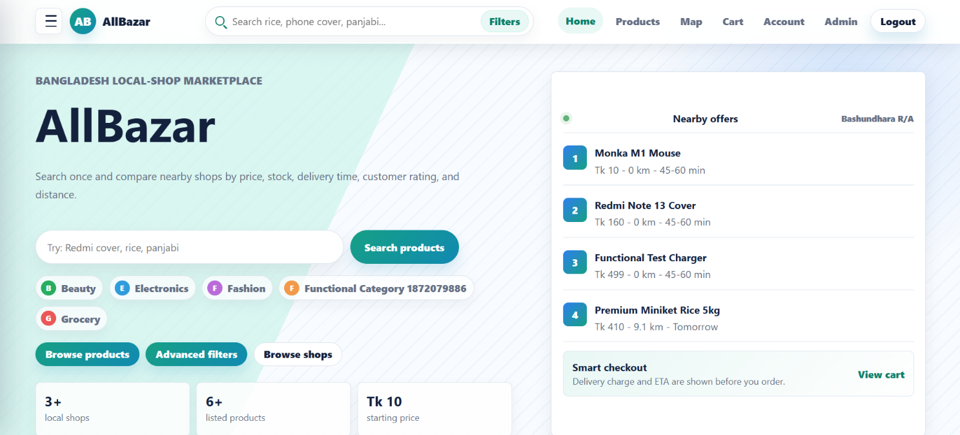

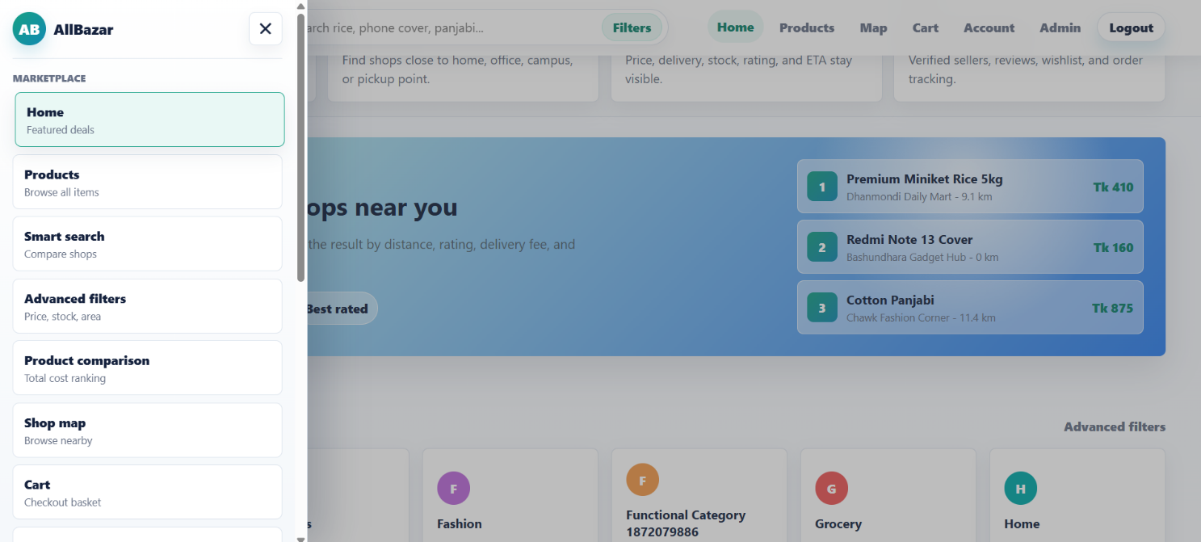

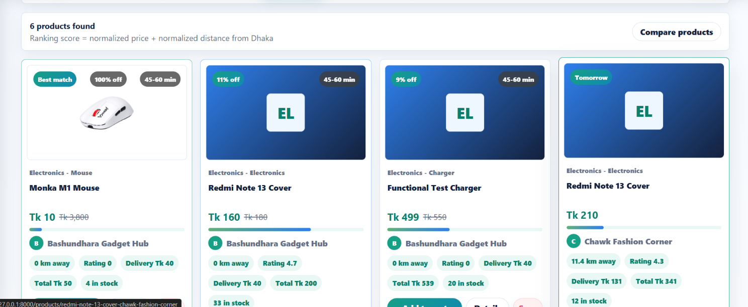
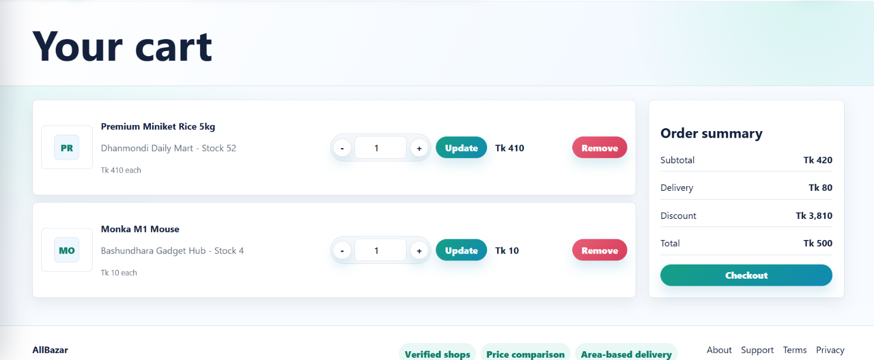
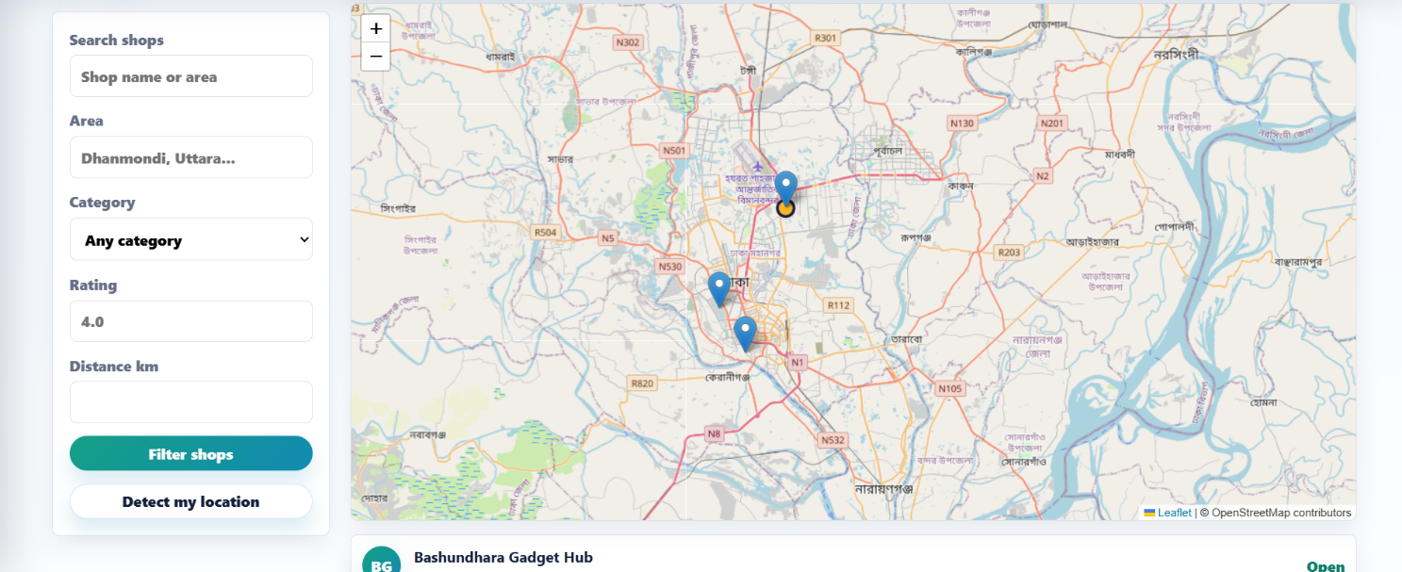
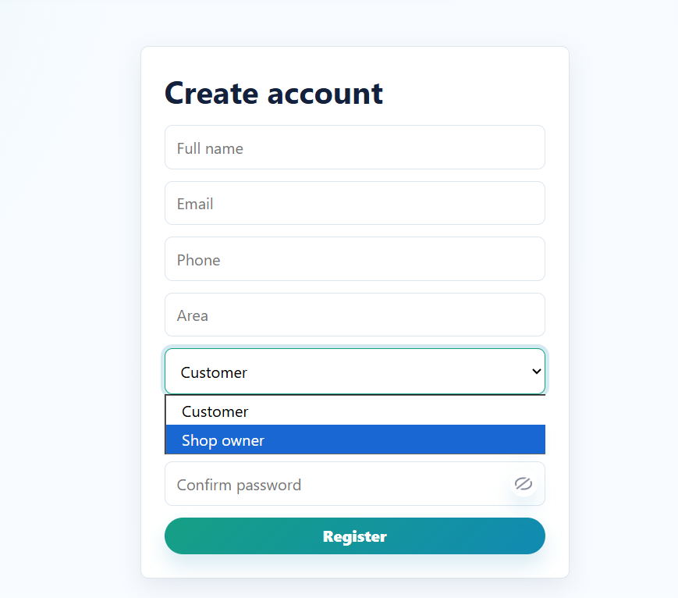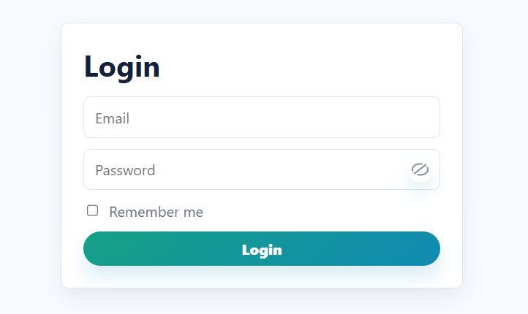
2.2 Use of Modern Tools
Category | Tools / Technologies
Language | PHP
Framework | Laravel
Frontend | HTML, CSS, JavaScript, Blade
Backend | Laravel MVC
Database | MySQL
Local Server | XAMPP
Code Editor | VS Code
UI Design | CSS, responsive layout
Version Control | Git and GitHub

2.3 Main Code

const siteHeader = document.querySelector('[data-site-header]');
const sidebar = document.querySelector('#site-sidebar');
const sidebarToggles = document.querySelectorAll('[data-sidebar-toggle]');
const sidebarClosers = document.querySelectorAll('[data-sidebar-close]');

const setSidebar = (isOpen) => {
document.body.classList.toggle('sidebar-open', isOpen);
sidebar?.setAttribute('aria-hidden', String(!isOpen));
sidebarToggles.forEach((button) => button.setAttribute('aria-expanded', String(isOpen)));
};

sidebarToggles.forEach((button) => {
button.addEventListener('click', () => setSidebar(!document.body.classList.contains('sidebar-open')));
});

sidebarClosers.forEach((button) => {
button.addEventListener('click', () => setSidebar(false));
});

sidebar?.querySelectorAll('a').forEach((link) => {
link.addEventListener('click', () => setSidebar(false));
});

document.addEventListener('keydown', (event) => {
if (event.key === 'Escape') setSidebar(false);
});

const updateHeaderState = () => {
siteHeader?.classList.toggle('is-scrolled', window.scrollY > 8);
};

updateHeaderState();
window.addEventListener('scroll', updateHeaderState, { passive: true });

document.querySelectorAll('[data-suggestions]').forEach((input) => {
const box = document.createElement('datalist');
box.id = `suggestions-${Math.random().toString(16).slice(2)}`;
input.setAttribute('list', box.id);
input.after(box);

let timer;
const loadSuggestions = () => {
clearTimeout(timer);
timer = setTimeout(async () => {
try {
const response = await fetch(`/search-suggestions?q=${encodeURIComponent(input.value)}`);
const names = await response.json();
box.innerHTML = '';
names.forEach((name) => {
const option = document.createElement('option');
option.value = name;
box.appendChild(option);
});
} catch (error) {
box.innerHTML = '';
}
}, 180);
};

input.addEventListener('focus', loadSuggestions);
input.addEventListener('input', loadSuggestions);
});

document.querySelectorAll('.zoom-gallery').forEach((gallery) => {
const mainArea = gallery.querySelector('[data-product-gallery-main]');
const mainImage = gallery.querySelector('[data-product-gallery-main] img');
const zoomPane = gallery.querySelector('[data-product-zoom-pane]');
const zoomImage = zoomPane?.querySelector('img');
const thumbs = gallery.querySelectorAll('[data-gallery-thumb]');

if (!mainArea || !mainImage) return;

const setImage = (src) => {
mainImage.src = src;
if (zoomImage) zoomImage.src = src;
};

thumbs.forEach((thumb) => {
thumb.addEventListener('click', () => {
setImage(thumb.dataset.imageSrc);
thumbs.forEach((item) => item.classList.toggle('is-active', item === thumb));
});
});

if (!zoomImage) return;

mainArea.addEventListener('mouseenter', () => {
gallery.classList.add('is-zooming');
zoomPane.setAttribute('aria-hidden', 'false');
});

mainArea.addEventListener('mouseleave', () => {
gallery.classList.remove('is-zooming');
zoomPane.setAttribute('aria-hidden', 'true');
zoomImage.style.transformOrigin = 'center center';
});

mainArea.addEventListener('mousemove', (event) => {
const rect = mainArea.getBoundingClientRect();
const x = Math.max(0, Math.min(100, ((event.clientX - rect.left) / rect.width) * 100));
const y = Math.max(0, Math.min(100, ((event.clientY - rect.top) / rect.height) * 100));
zoomImage.style.transformOrigin = `${x}% ${y}%`;
});
});

document.querySelectorAll('.cart-item input[type="number"]').forEach((input) => {
input.addEventListener('input', () => {
if (Number(input.value) < 1) input.value = 1;
});
});

document.querySelectorAll('.password-field').forEach((field) => {
const input = field.querySelector('[data-password-input]');
const toggle = field.querySelector('[data-password-toggle]');

if (!input || !toggle) return;

input.type = 'password';
toggle.classList.add('is-hidden');
toggle.setAttribute('aria-label', 'Show password');

toggle.addEventListener('click', () => {
const isVisible = input.type === 'text';
input.type = isVisible ? 'password' : 'text';
toggle.classList.toggle('is-hidden', isVisible);
toggle.setAttribute('aria-label', isVisible ? 'Show password' : 'Hide password');
});
});

document.querySelectorAll('[data-quantity-stepper]').forEach((stepper) => {
const input = stepper.querySelector('input[type="number"]');
stepper.querySelectorAll('[data-step]').forEach((button) => {
button.addEventListener('click', () => {
const step = Number(button.dataset.step);
const min = Number(input.min || 1);
const max = Number(input.max || 9999);
const next = Math.min(max, Math.max(min, Number(input.value || min) + step));
input.value = next;
input.dispatchEvent(new Event('input', { bubbles: true }));
});
});
});

document.querySelectorAll('form').forEach((form) => {
form.addEventListener('submit', () => {
form.querySelectorAll('button[type="submit"], button:not([type])').forEach((button) => {
button.dataset.originalText = button.textContent;
button.textContent = 'Working...';
button.disabled = true;
});
});
});

Chapter 3

Implementation and Results

This chapter describes the implementation process of the AllBazar: A Local Marketplace Web Application. It explains how the system was developed using Laravel following the MVC architecture, including the design and integration of core modules such as authentication, product management, user management, cart, and order processing. The chapter also presents the results obtained from the system, including user interfaces, system functionality, and performance outcomes. Key features such as role-based access control, product search, and user profile management are also discussed.

3.1 Implementation

The system is implemented using MVC architecture.
MVC Diagram

Model
Models were used to represent database tables such as users, shops, products, orders, reviews, wishlists, addresses, and categories.

View
Blade templates were used to create pages such as homepage, product search, product details, shop profile, cart, checkout, customer dashboard, shop-owner dashboard, and admin dashboard.

Controller
Controllers were used to handle business logic such as user registration, product search, cart operations, checkout, order processing, shop management, product management, reviews, wishlist, and admin operations.

Middleware
Middleware was used to protect admin and shop-owner routes from unauthorized access.

Database
MySQL database was used to store all system data. Laravel migrations were used to create and manage database tables.

3.2 Output

The final output of the project is a working local marketplace website called AllBazar. The website allows customers, shop owners, admins, and co-admins to perform different operations according to their roles.

Homepage Output
The homepage displays a marketplace hero section, search bar, product categories, featured shops, popular products, nearby products, today’s deals, and marketplace statistics. The design is responsive and user-friendly.

Search Output
The product search system allows users to search for products by name, category, and type. Search results are grouped and ranked based on price, distance, and rating.

Advanced Search Output
The advanced search page allows users to filter products by price, distance, delivery cost, category, shop rating, product rating, stock, and area.

Product Detail Output
The product detail page displays product images, zoom feature, price, discount, description, stock, rating, delivery cost, ETA, shop information, reviews, related products, and recently viewed products.

Shop Profile Output
The shop profile page displays shop banner, logo, name, area, distance, rating, phone, address, products, categories, and reviews.

Shop Map Output
The shop map page displays shops using a map-style grid. Users can filter shops by name, area, category, rating, and distance.

Cart Output
The cart page displays selected products, quantity, unit price, line total, subtotal, delivery charge, discount, and total amount. Users can update or remove cart items.

Checkout Output
The checkout page collects recipient name, phone number, delivery address, area, city, payment method, and order notes. It also displays an order summary.

Customer Dashboard Output
The customer dashboard displays profile information, saved address count, wishlist count, order history, wishlist products, and submitted reviews.

Shop Owner Dashboard Output
The shop owner dashboard displays shop overview, products, recent orders, and options to register/update shop and manage products.

Admin Dashboard Output
The admin dashboard allows admins to manage users, roles, co-admins, shops, products, categories, orders, and support messages.

3.3 Discussion

AllBazar successfully provides a local marketplace solution for Bangladesh. The platform is more advanced than a simple e-commerce website because it supports multiple shops, product comparison, shop-based product listing, distance-based ranking, and shop-owner management.
The system provides benefits for both customers and shop owners. Customers can search products online and compare prices from nearby shops. Shop owners can list products and reach more customers without building their own website.
The project also demonstrates important web engineering concepts such as authentication, authorization, CRUD operations, MVC architecture, database design, session-based cart management, role-based access, responsive design, and admin control.
Although the current system is functional, future improvements can make it more powerful by adding real map integration, real-time tracking, online payment gateway, rider dashboard, notification system, and analytics dashboard.

Chapter 4

Engineering Standards and Mapping
AllBazar has a positive impact on society because it helps local shops become digitally accessible. Many small businesses in Bangladesh do not have their own websites or online selling platforms. AllBazar provides them with a marketplace where they can list products and reach more customers.
The system also helps customers save time and effort. Instead of visiting many shops physically, customers can search and compare products online. This improves convenience and reduces unnecessary travel.

4.1.1 Impact on Life
AllBazar can improve daily life in several ways:
- Customers can find products faster.
- Customers can compare prices from multiple shops.
- Customers can discover nearby shops.
- Shop owners can increase sales.
- Local businesses can gain online visibility.
- Users can place orders from home.
- Product availability can be checked before visiting a shop.
- Customers can make better purchasing decisions through ratings and reviews.
The system is especially useful for busy customers, students, office workers, families, and people who want to save time while shopping.

4.1.2 Impact on Society and Environment

Social Impact
AllBazar supports digital transformation in local commerce. It helps small and medium shops compete with larger online platforms. The platform also creates a bridge between local sellers and customers.
Social benefits include:
- Support for small businesses.
- Better access to local products.
- Increased digital literacy among shop owners.
- More transparent product pricing.
- Improved customer trust through reviews and ratings.

Environmental Impact
AllBazar can reduce unnecessary travel because customers can check product availability and compare shops online before going outside. This may help reduce fuel usage and traffic in urban areas.
Environmental benefits include:
- Less unnecessary shop-to-shop travel.
- Better delivery planning.
- Reduced time spent searching physically.
- More efficient local shopping.

Sustainability
The project is sustainable because it uses open-source technologies and can be expanded over time. New modules such as payment gateway, rider dashboard, notification system, and analytics can be added without rebuilding the whole system.

4.2 Complex Engineering Problem
AllBazar solves a complex engineering problem because it combines multiple systems into one platform. It includes user management, shop management, product management, product search, ranking logic, cart, checkout, reviews, wishlist, support, and admin control.
The complexity comes from:
- Multiple user roles.
- Multiple shops.
- Product comparison.
- Price and distance-based ranking.
- Advanced filtering.
- Order processing.
- Shop-owner dashboard.
- Admin and co-admin management.
- Database relationships.
- Responsive user interface.

4.2.1 Mapping of Program Outcome
In this section, provide a mapping of the problem and provided solution with targeted Program Outcomes (PO’s).
Table 4.1: Justification of Program Outcomes

POs | Justification of Mapping (Project Perspective)
PO1 | The project applies programming, database, web development, and software design knowledge.
PO5 | The project uses Laravel, PHP, MySQL, HTML, CSS, JavaScript, XAMPP, VS Code, and GitHub.
PO9 | The project can be developed by a team where different members work on frontend, backend, database, testing, and documentation.
PO10 | The project includes report writing, presentation, design explanation, and code documentation.

4.2.2 Complex Problem Solving

Table 4.2: Mapping with complex problem solving.
EP1  Dept of  Knowledge | EP2  Range of  Conflicting  Requirements | EP3  Depth of  Analysis | EP4  Familiarity of Issues | EP5  Extent of  Applicable Codes | EP6  Extent  Of  Stakeholder  Involvement | EP7  Inter-  dependence
 |  |  |  |  |  | 

EP1: Depth of Knowledge Required
The development of ShopWave requires strong knowledge of web technologies, including PHP, Laravel framework, database management (MySQL), and frontend design using Tailwind CSS. It also involves understanding MVC architecture, authentication mechanisms, and role-based access control.
EP2: Range of Conflicting Requirements
The system addresses conflicting requirements such as ensuring security while maintaining usability, providing admin control while allowing user flexibility, and balancing performance with feature richness. For example, implementing secure authentication without affecting user experience.
EP3: Depth of Analysis Required
The project involves detailed analysis of system requirements, database design, and user workflows. Features like product search, cart management, and order processing require careful logical design and efficient data handling.
EP4: Familiarity of Issues
E-commerce systems are common in the industry, but implementing a complete system with role-based access, secure transactions, and dynamic product management introduces moderate complexity. The project builds upon known concepts but requires customization and integration.
EP5: Extent of Applicable Codes
The project uses established frameworks and coding standards such as Laravel’s MVC structure,
authentication systems, routing, and validation. It follows best practices for secure coding, database handling, and modular development.
EP6: Extent of Stakeholder Involvement
The system considers multiple stakeholders, including administrators (who manage products and users) and customers (who browse, purchase, and manage profiles). The design ensures that each stakeholder’s needs are properly addressed.
EP7: Interdependence of Components
The application consists of interconnected modules such as authentication, product management, cart, and order processing. These components depend on each other—for example, orders depend on cart data, and cart operations depend on user authentication.

4.2.3 Complex Engineering Activities

Table 4.2: Mapping with complex engineering activities.
EA1 | EA2 | EA3 | EA4 | EA5
 |  |  |  | 

EA1: Knowledge Application and Problem Solving
In this project, systematic engineering methods are followed to design and develop the ShopWave ecommerce system. The application integrates backend logic, database management, and frontend design using Laravel, MySQL, and Tailwind CSS. The system is structured using MVC architecture to ensure modularity, scalability, and efficient problem-solving.
EA2: Communication and Presentation
The project involves clear documentation, report writing, and presentation of system architecture, features, and results. Visual elements such as diagrams (MVC, use case) and UI screenshots are used to effectively communicate design decisions and system functionality.
EA3: Use of Modern Tools and Techniques
The system is developed using modern tools such as Laravel framework, VS Code, XAMPP, and MySQL. Version control practices and structured coding techniques are followed to ensure efficient development and maintenance.
EA4: Design and Development of Solutions
The project involves designing a complete e-commerce solution including authentication, product management, cart system, and order processing. Each module is carefully implemented and integrated to ensure smooth system functionality.
EA5: Testing and Validation
The system is tested for functionality, usability, and performance. Different modules such as login, product CRUD, cart, and order system are verified to ensure correct operation and error handling.

Chapter 5

Conclusion

5.1 Summary

AllBazar is a local marketplace web application developed for Bangladesh. It allows customers to search for products from nearby shops, compare prices, view shop details, add products to cart, place orders, save wishlist items, and write reviews.
The system also provides shop-owner features for registering shops, adding products, uploading images, managing stock, and viewing orders. Admins and co-admins can manage users, shops, products, categories, orders, support messages, and roles.The project was developed using Laravel, PHP, MySQL, HTML, CSS, JavaScript, and XAMPP. It follows MVC architecture, making the code organized, maintainable, and scalable.Overall, AllBazar successfully demonstrates the concept of a local multi-shop marketplace where price comparison, distance-based product ranking, and shop management are combined into one web platform.

5.2 Limitation

Although AllBazar is functional, it has some limitations:
- The shop map is currently map-style and may not use real Google Maps or OpenStreetMap.
- Online payment gateway may not be fully integrated.
- Real-time rider tracking is not available.
- Delivery rider dashboard is not included.
- Product comparison can be improved further.
- Notification system may be limited.
- Refund and return system is not fully implemented.
- Advanced analytics dashboard is not available.
- Email or phone OTP verification may not be implemented.
- Real-time chat between customer and shop owner is not available.
- Product recommendation system can be improved.

5.3 Future Work

The following features can be added in the future:
- Real Google Maps or OpenStreetMap integration.
- Live customer location detection.
- Real-time shop distance calculation.
- Delivery rider dashboard.
- Rider assignment system.
- Live order tracking.
- bKash, Nagad, Rocket, and SSLCommerz payment gateway integration.
- Product comparison page.
- Coupon and promo code system.
- Return and refund system.
- Admin analytics dashboard.
- Shop owner analytics dashboard.
- Notification system.
- Email verification.
- Phone OTP verification.
- Two-factor authentication for admin.
- Review moderation system.
- Verified shop badge.
- Shop document verification.
- Product variant system for size, color, weight, model, etc.
- Multi-shop cart splitting.
- Invoice download system.
- Mobile app version.

5.4 Github & YT Link
Github Link: https://github.com/ArhabJahin/ALL_Bazar.git
YouTube Link: https://youtu.be/cxM4wZLevfg

References

- Laravel Documentation. (2024). Laravel - The PHP Framework for Web Artisans. Available at: https://laravel.com/docs

- PHP Documentation Group. (2024). PHP Manual.
Available at: https://www.php.net/manual/en/

- MySQL Documentation. (2024). MySQL Reference Manual. Available at: https://dev.mysql.com/doc/

- Tailwind CSS. (2024). Tailwind CSS Documentation. Available at: https://tailwindcss.com/docs

- Mozilla Developer Network (MDN). (2024). Web Development Guide. Available at: https://developer.mozilla.org/

- Welling, L., & Thomson, L. (2017). PHP and MySQL Web Development (5th ed.). Pearson.

- Gamma, E., Helm, R., Johnson, R., & Vlissides, J. (1994). Design Patterns: Elements of Reusable Object-Oriented Software. Addison-Wesley.

- Pressman, R. S. (2014). Software Engineering: A Practitioner’s Approach (8th ed.). McGraw-Hill.

